My Home Blood Pressure Diary
Name:
Date of Birth:
Date | Morning BP | Morning Pulse | Evening BP | Evening Pulse | Notes
Day 1
Day 2
Day 3
Day 4

Average: /
How to Work Out Your Average:
Ignore Day 1 (practice day).
Add all the top numbers (systolic) and divide by how many readings you did.
Do the same for the bottom numbers (diastolic).
Choosing a Monitor:
Use a monitor that is clinically checked. See the link below or ask a pharmacy.
www.bihsoc.org/bp-monitors/for-home-use
Where to Buy:
You can buy monitors from the maker, at local pharmacies (Boots, Lloyds), or online (Amazon, John Lewis).
Before You Measure:
- Wait 30 mins after eating, smoking, coffee, or exercise.
- Use the same arm your doctor uses.
- Wear loose clothes.
- Sit quietly for 5 mins.
- Rest your arm at heart level.
- Keep feet flat and stay relaxed.
How to Measure:
Watch this video: https://youtu.be/AXCFcftkric
1. Follow your monitor’s instructions.
2. Put cuff 2cm above elbow.
3. Sit still, don’t cross legs.
4. Take 2 readings, 1–2 mins apart, morning and evening for 4 days.
5. If readings differ a lot, take 2–3 more.
6. Write numbers exactly as shown.
7. Return diary (and monitor if borrowed) to your GP.
Helpful Links:
- Blood Pressure UK: http://www.bloodpressureuk.org/your-blood-pressure/how-to-lower-your-blood-pressure/monitoring-your-blood-pressure-at-home/
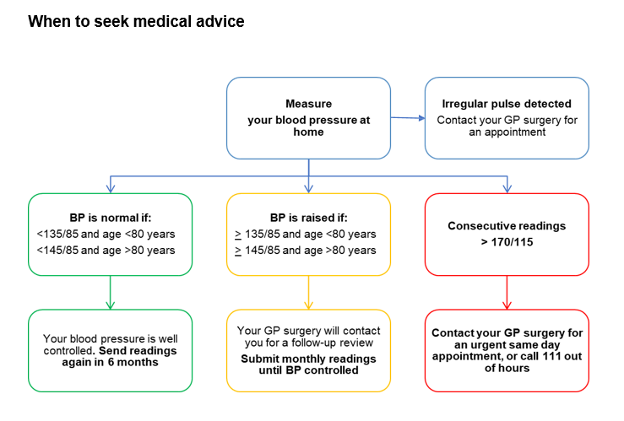
- NHS Guide: https://www.england.nhs.uk/ourwork/clinical-policy/cvd/home-blood-pressure-monitoring/

KEY
< Less than
> More than

